Practical:1

Aim:-Introduction to computer

-computer characteristics
- Speed: Computers can perform millions or billions of operations per second.
- Accuracy: They give very precise results if correct data is provided.
- Diligence: They do not get tired or bored, can work continuously.
- Storage: Large amount of data can be stored and retrieved easily.
- Automation: Once programmed, they can perform tasks automatically.
- Versatility: Can be used for different tasks like study, business, entertainment, etc.
- Reliability: Produces consistent results without errors (if input is correct).
- Multitasking: Can perform multiple tasks at the same time.
-Concept Of Hardware
- Hardware refers to the physical parts of a computer system that we can see and touch.
- It includes devices like keyboard, mouse, monitor, CPU, printer, and storage devices.
- Hardware works together with software to perform computer operations.
- It is mainly divided into input devices, output devices, processing unit, and storage devices.
- Without hardware, a computer cannot function.
- Hardware receives data, processes it, and displays the result with the help of software.
-Software
- Software is a set of programs and instructions that tell a computer what to do.
- It is not physical; we cannot touch it.
- Software works together with hardware to operate a computer system.
- It is mainly of two types: System Software and Application Software.
- System software helps the computer run (e.g., operating system).
- Application software is used for specific tasks like typing, browsing, or calculations.
- Examples include Windows, MS Word, and web browsers.
-Evolution Of Computer and Generations
- The evolution of computers refers to the development and improvement of computers over time.
- Computers have become smaller, faster, more powerful, and more efficient through different generations.

First Generation (1940–1956)
- Used vacuum tubes
- Very large, expensive, and slow
- Produced a lot of heat
- Example: ENIAC

Second Generation (1956–1963)
- Used transistors instead of vacuum tubes
- Smaller, faster, and more reliable
- Less heat production

Third Generation (1964–1971)
- Used integrated circuits (ICs)
- Much smaller and faster
- Improved performance and efficiency

Fourth Generation (1971–Present)
- Used microprocessors
- Personal computers (PCs) became popular
- Very fast, small, and affordable

Fifth Generation (Present & Future)
- Based on Artificial Intelligence (AI)
- Focus on smart systems, robotics, and machine learning
- Aim to make computers more intelligent and human-like
- Overall, each generation improved speed, size, cost, and performance of computers.
-Types Of Computers
- Computers are classified into different types based on size, purpose, and data handling capacity.

1. Based on Size
- Microcomputer: Small and personal computers like desktops, laptops, and smartphones.
- Minicomputer: Medium-sized computers used by small organizations.
- Mainframe Computer: Large and powerful computers used by big companies for bulk data processing.
- Supercomputer: Fastest and most powerful computers used for complex tasks like weather forecasting and scientific research.

2. Based on Purpose
- General Purpose Computers: Used for everyday tasks like browsing, typing, and office work.
- Special Purpose Computers: Designed for a specific task like traffic control or medical machines.

3. Based on Data Handling
- Analog Computers: Work on continuous data (used in scientific measurements).
- Digital Computers: Work on binary data (0 and 1), most common type.
- Hybrid Computers: Combination of analog and digital systems
-Various Operating Systems
- An Operating System (OS) is system software that manages computer hardware and software and provides a user interface.

Common Operating Systems:
- Microsoft Windows: Most widely used OS for personal and office computers, developed by Microsoft.
- macOS: Developed by Apple for Apple computers (Mac). Known for smooth performance and security.
- Linux: Open-source operating system used in servers, programming, and advanced computing.
- Android: Mobile operating system developed by Google, used in most smartphones.
- iOS: Mobile OS developed by Apple for iPhones and iPads.
- Operating systems help manage files, memory, processes, and input/output devices efficiently.
-Window Os Feature
- Windows OS is an operating system developed by Microsoft.
- It provides a graphical user interface (GUI) with icons, menus, and windows.
- Supports multitasking, allowing multiple programs to run at the same time.
- Easy to use with mouse and keyboard support.
- Includes built-in applications like File Explorer, Notepad, and Settings.
- Provides security features like Windows Defender and user accounts.
- Supports a wide range of hardware and software.
- Allows file management, storage, and sharing easily.
- Regular updates improve performance and security.

Bottom of Form

Practical:2

Aim:- Introduction of MS Word

-Components of Ms Word
- Microsoft Word is a word processing software developed by Microsoft used for creating and editing documents.

Main Components:
- Title Bar: Shows the name of the document and program.
- Quick Access Toolbar: Contains frequently used commands like Save, Undo, and Redo.
- Ribbon: Main area with tabs like Home, Insert, Design, etc., containing tools and commands.
- File Menu (Backstage View): Used for creating, opening, saving, and printing documents.
- Document Area: The main working space where text is typed and edited.
- Rulers: Help in setting margins, tabs, and alignment.
- Scroll Bars: Used to move up, down, or sideways in a document.
- Status Bar: Shows information like page number, word count, and zoom level.
- View Options: Allows changing document views (Read Mode, Print Layout, Web Layout).
-File:- Create ,Edit ,Save ,Open ,Image insert ,Table work ,and Print Documents ,Spelling and Grammar check ,Mail merge

MS Word File Operations & Features
- Microsoft Word is a word processing software developed by Microsoft used for creating and managing documents.

File Operations:
- Create: Used to make a new document.
- Open: Used to open an existing saved document.
- Edit: Used to modify or change text and content in a document.
- Save: Used to store the document for future use.
- Print: Used to take a printed copy of the document.

Important Features:
- Insert Image: Allows adding pictures, charts, and shapes into a document.
- Table Work: Used to create tables for organizing data in rows and columns.
- Spelling & Grammar Check: Helps detect and correct spelling and grammar mistakes.
- Mail Merge: Used to create multiple personalized documents (like letters or invitations) using a single template.

Practical:3
Aim:- To learn and practice document creation in Microsoft Word by using formatting features such as bold, underline, font style, font size, and font color, and to apply editing operations using Find & Replace, Cut, Copy, Paste, and Clipboard tools, along with inserting Date & Time, Pictures, Bullets, and Numbering to enhance the document presentation.

1. Creating Documents with Special Effects

Aim
To create a document using formatting features like bold, underline, font style, font size, and font color.

Sample
- Title in Bold
- Name in Italic
- Important text with <u>Underline</u>
- Different font sizes and colors

Example
COMPUTER APPLICATIONS
Name: Rahul Sharma
Course: BCA
Subject: <u>MS Word Practical</u>

2. Find, Replace, Cut, Copy, Paste & Clipboard

Aim
To learn editing operations using Find & Replace, Cut, Copy, Paste, and Clipboard tools.

Sample
- Replace “Computer” with “Laptop”
- Copy one paragraph and paste it elsewhere
- Cut unwanted text

Example
Original:
“Computer is an electronic device.”
After Replace:
“Laptop is an electronic device.”

3. Inserting Date, Time, Pictures, Bullets & Numbering

Aim
To insert Date & Time, Pictures, Bullets, and Numbering in a document.

Sample
Date: 26 May 2026
Time: 10:30 AM

Bullets Example
- MS Word
- MS Excel
- MS PowerPoint

Numbering Example
- Open MS Word
- Type Text
- Save Document

Practical:4
Aim:- To learn and apply paragraph formatting in Microsoft Word using alignment, indentation, line spacing, and bullets, and to understand printing options such as paper size, margins, header, footer, and page numbers, along with creating and formatting tables to organize data effectively.

1. Paragraph Formatting, Bullets & Indentation

Aim
To format paragraphs using alignment, indentation, line spacing, and bullets.

Sample
- Left Alignment
- Center Alignment
- Right Alignment
- Justify Text
- First Line Indent

Example Paragraph
“MS Word is a word processing software used to create professional documents.”

2. Printing Documents & Page Setup

Aim
To learn printing options such as paper size, margins, header, footer, and page numbers.

Sample
- Paper Size: A4
- Margin: Normal
- Header: College Name
- Footer: Page Number

Example
Header: ABC College of Computer Science
Footer: Page 1

3. Creating a Table
Aim
To create and format tables in MS Word.
Roll No | Name | Course
0056 | yash | Diploma
0041 | mamik | Diploma
0064 | sahil | Diploma
0055 | tanmay | Diploma
0054 | prince | Diploma
0058 | rudra | Diploma
0020 | shivam | Diploma
0025 | bhavik | Diploma
0052 | gautum | Diploma

Practical:5

Aim:-To learn and practice using tools in Microsoft Word for checking spelling and grammar mistakes, drawing and customizing tables using the Draw Table option, and creating professional documents using predefined templates.

1. Spell Check & Grammar Check
Aim:-To check spelling and grammar mistakes using MS Word tools.

Sample

Incorrect: “Compter”
Corrected: “Computer”

2. Drawing Table

Aim:-To draw and customize tables manually using Draw Table option.

Sample
- Create rows and columns manually
- Apply borders and shading

3. Using Templates

Aim:-To create documents using predefined templates.

Sample
- Resume Template
- Report Template
- Invitation Template

Example
Create a Resume using MS Word template containing:
- Name
- Qualification
- Skills
- Contact Details

Practical:6

Aim:-Introduction to MS Excel

-Introduction of Spreadsheet: Create, Edit, Save, Print, functions & formulas, Worksheets modification with colour & auto-formats

Introduction to Spreadsheet — Short Note
- A Spreadsheet is an application used to store, organize, and analyze data in rows and columns.
- Example: Microsoft Excel developed by Microsoft.

Basic Operations:
- Create: Used to make a new spreadsheet file.
- Open: Used to open an existing spreadsheet.
- Edit: Used to modify data in cells.
- Save: Used to store work for future use.
- Print: Used to take a hard copy of data.

Functions & Formulas:
- Used to perform calculations automatically.
- Examples: SUM, AVERAGE, MAX, MIN, etc.
- Formulas start with the “=” sign.

Worksheet Modification:
- Color formatting: Used to highlight important data.
- Auto-format: Applies ready-made styles to tables for better presentation.
- Helps make data more clear, attractive, and organized.

Practical:7
Aim:-To create and save worksheets using Microsoft Excel.

Practical Sample
- Open Excel
- Create a new workbook
- Enter student data
- Save the file as Student_Record.xlsx
Roll No | Name | Marks
101 | Amit Chauhan | 85
102 | Neha Chauhan | 90
103 | Rahul Chauhan | 78
104 | Amit Gohel | 85
105 | Neha Gohel | 90
106 | Rahul Gohel | 78
107 | Amit Jadav | 85
108 | Neha Jadav | 90
109 | Rahul Jadav | 78

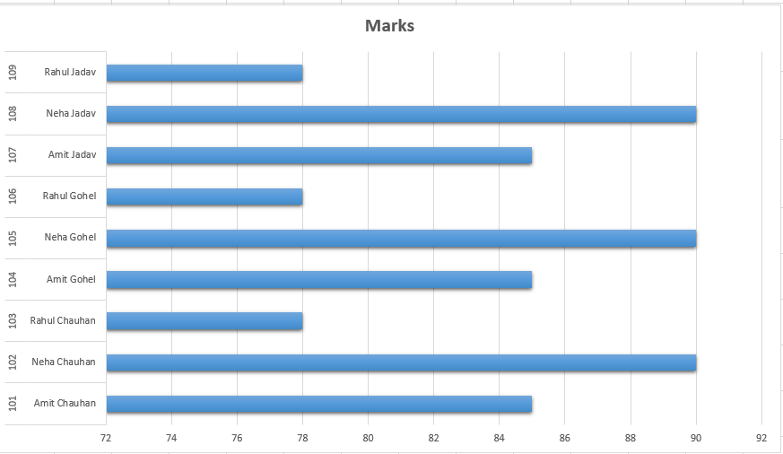

Practical:8
Aim:-To perform worksheet management operations.

Practical Sample
- Insert a new worksheet
- Rename worksheet
- Copy Sheet1 to Sheet2
- Delete unwanted worksheet
- Print worksheet using Print Preview

Example
- Sheet Name: “Sales Report”
- Print Area: A1:D10
Sheet Name: Sales Report
Product | Quantity | Price | Total
Laptop | 2 | 4500 | 9000
Mouse | 5 | 5000 | 25000
Keyboard | 3 | 1200 | 3600
Apple | 200 | 5000 | 10000
Banana | 500 | 7000 | 45000
Mango | 300 | 3000 | 9000
Grapes | 500 | 8000 | 40000
Watermelon | 300 | 5000 | 15000

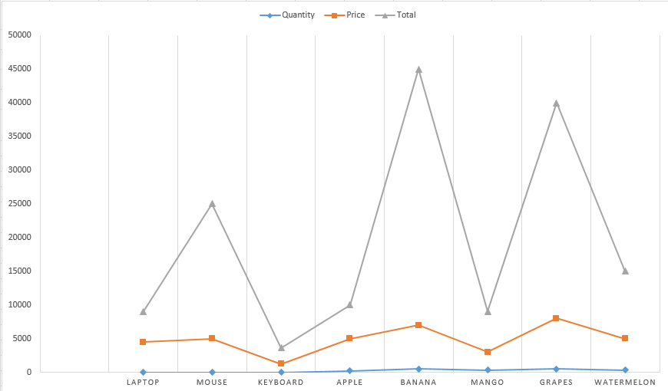

Practical:9
Aim:-To create and organize a fruit name list in Microsoft Excel using rows, columns, and tables, and to create charts for graphical representation of the data.
Sr. No | Category | Fruit Name | Sales
1 | Common Fruits | Apple | 10000
2 | Common Fruits | Banana | 10000
3 | Common Fruits | Mango | 5000
4 | Common Fruits | Orange | 10000
5 | Common Fruits | Grapes | 7000
6 | Common Fruits | Pineapple | 9000
7 | Common Fruits | Papaya | 10000
8 | Common Fruits | Watermelon | 7000
9 | Common Fruits | Guava | 8000
10 | Common Fruits | Strawberry | 10000

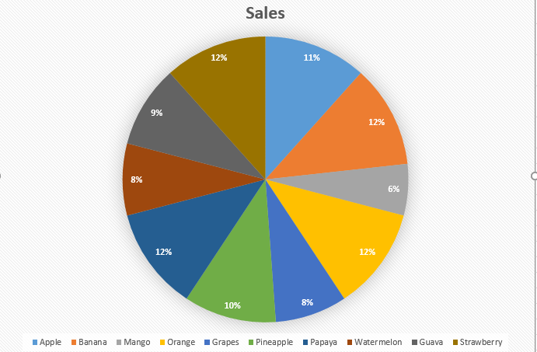

Practical:10

Aim:- Introduction to MS PowerPoint

-Components of MS PowerPoint: Create, Open, view, print slides, layouts editing, Presentation
- Microsoft PowerPoint is a presentation software developed by Microsoft used to create slide-based presentations.

Basic Operations:
- Create: Used to make a new presentation.
- Open: Used to open an existing presentation file.
- View: Allows different views like Normal, Slide Sorter, and Slide Show.
- Print Slides: Used to print slides, notes, or handouts.

Layouts & Editing:
- Slide Layouts: Pre-designed structures for arranging text, images, and content.
- Editing Slides: Used to add or modify text, images, charts, and design elements.

Presentation:
- Slide Show Mode: Used to display slides one by one for an audience.
- Supports animations, transitions, and multimedia for effective presentation.

Practical:11
Aim:-To create a professional presentation using Microsoft PowerPoint.
-slide1

-slide2

-slide3
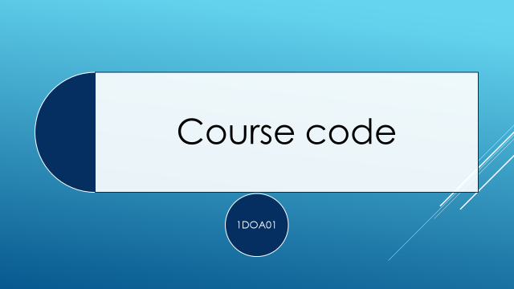

Practical:12
Aim:-To learn how to insert, duplicate, and delete slides in a presentation.
-slide1
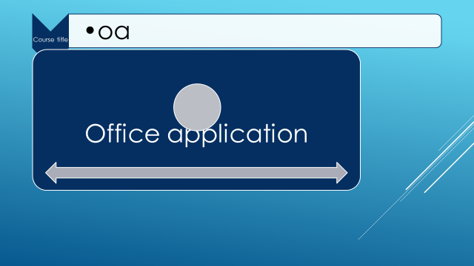
-slide2
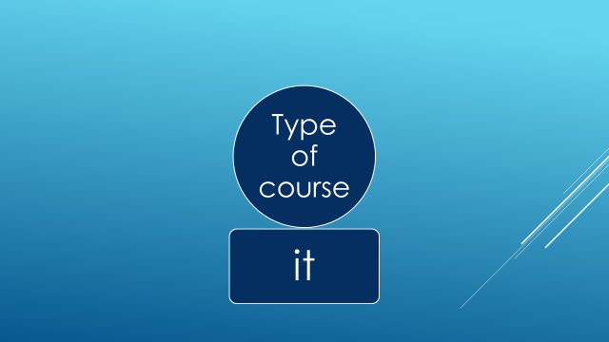
-slide3


Practical:13
Aim:-To understand and use different slide views such as Normal View, Slide Sorter View, Reading View, and Slide Show View.
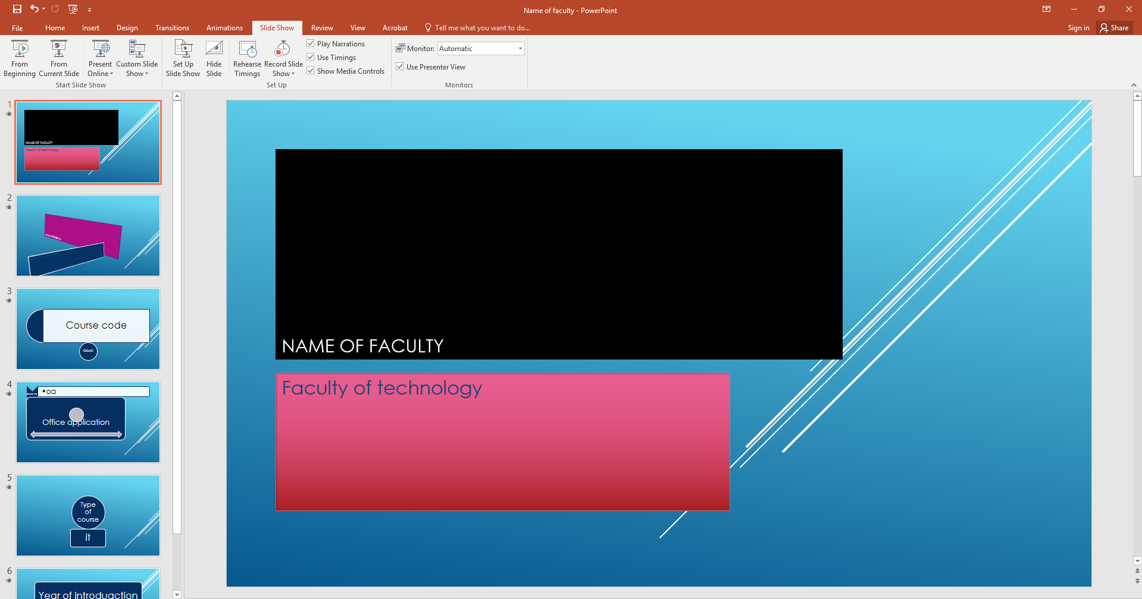

Practical:14

Aim:-Use Of Google Application

-Google chrome
- Developed by Google. 5
- A fast, secure, and widely used web browser.
- First released in 2008.
- Built on the Chromium open-source project.
- Supports tabs, extensions, bookmarks, and sync features.
- Uses the Blink rendering engine and V8 JavaScript engine.
- Available for Windows, macOS, Linux, Android, and iOS.
- Provides features like Incognito Mode, password manager, and Safe Browsing.
- Commonly used for web browsing, online learning, streaming, and web apps.
-Gmail
- Gmail is a free email service developed by Google.
- It was launched in 2004.
- Users can send and receive emails through the internet.
- Provides features like spam filtering, search, file attachments, and video meetings.
- Integrates with services such as Google Drive, Google Meet, and Google Calendar.
- Available on web browsers and mobile apps.
- Known for its user-friendly interface and strong security features.
-Google Calender
- Google Calendar is an online calendar service developed by Google.
- It helps users organize schedules, events, and reminders.
- Launched in 2006.
- Users can create and manage meetings, tasks, and appointments.
- Supports event notifications and reminders through email or mobile alerts.
- Integrates with Gmail, Google Meet, and other Google services.
- Available on web browsers and mobile devices.
- Useful for personal planning, study schedules, and office work.
-Google Search
- Google Search is a web search engine developed by Google.
- It helps users find information on the internet.
- Launched in 1998.
- Users can search for websites, images, videos, news, maps, and documents.
- Provides fast and accurate search results using advanced algorithms.
- Supports voice search and search suggestions.
- Widely used for education, research, entertainment, and daily information needs.
- Accessible through web browsers and mobile devices.

-Google Docs
- Google Docs is an online word processing application developed by Google.
- It allows users to create, edit, and share documents online.
- Part of the Google Workspace suite.
- Supports real-time collaboration with multiple users.
- Documents are automatically saved in Google Drive.
- Provides features like formatting, comments, templates, and spell check.
- Accessible through web browsers and mobile apps.
- Commonly used for school projects, office work, and report writing.
-Google Sheets
- Google Sheets is an online spreadsheet application developed by Google.
- It is used to create, edit, and manage spreadsheets online.
- Part of the Google Workspace suite.
- Supports formulas, charts, tables, and data analysis.
- Allows real-time collaboration with multiple users.
- Automatically saves files in Google Drive.
- Accessible through web browsers and mobile apps.
- Commonly used for calculations, budgeting, data management, and reports.
-Google Presentations
- Google Slides is an online presentation application developed by Google.
- It is used to create, edit, and share presentations online.
- Part of the Google Workspace suite.
- Supports themes, animations, images, charts, and multimedia content.
- Allows real-time collaboration with multiple users.
- Presentations are automatically saved in Google Drive.
- Accessible through web browsers and mobile apps.
- Commonly used for school projects, business meetings, and seminars.
-Google Maps
- Google Maps is a digital mapping and navigation service developed by Google.
- It helps users find locations, routes, and nearby places.
- Provides maps, satellite images, and street views.
- Supports navigation for driving, walking, cycling, and public transport.
- Offers real-time traffic updates and travel information.
- Allows users to search for restaurants, hospitals, hotels, and other places.
- Available on web browsers and mobile apps.
- Commonly used for travel, navigation, and location sharing.
-Google Drive
- Google Drive is a cloud storage service developed by Google.
- It allows users to store, manage, and share files online.
- Launched in 2012.
- Supports documents, images, videos, and other file types.
- Files can be accessed from any device with internet access.
- Integrates with Google Docs, Sheets, Slides, and Gmail.
- Provides file sharing and collaboration features.
- Available on web browsers and mobile apps.
- Commonly used for backup, file sharing, and online collaboration.
-Google Contacts
- Google Contacts is an online contact management service developed by Google.
- It helps users store and organize phone numbers, emails, and contact details.
- Automatically syncs contacts across Android devices and Google services.
- Integrates with Gmail, Google Meet, and Google Calendar.
- Allows users to create labels (groups) for easy organization.
- Contacts are stored securely in the cloud.
- Available on web browsers and mobile devices.
- Useful for managing personal, school, and professional contacts.

