Web-Enabled Patient & Nursing Student Council Platform.

Abstract:
Modern healthcare requires dynamic, digital-first communication models to streamline clinical education and patient engagement. While nursing student councils primarily focus on professional development, integrating them with active patient councils creates a robust feedback loop that enhances healthcare delivery and digital health literacy.

Objective:
To design, deploy, and evaluate a responsive, interactive WebTech platform. The system connects the Nursing Student Council with patient representatives, creating an ecosystem for collaborative problem-solving, real-time feedback on clinical care experiences, and decentralized patient education

Methods:
The platform was built using modern Web Technologies (WebTech), incorporating a React.js front-end for seamless user interaction, Node.js for backend data processing, and MongoDB for secure data storage. Features include:
Interactive Dashboard:
Secure role-based access for nursing students, educators, and patient representatives.

- Patient Feedback Portal:

Streamlined, multi-lingual digital forms for patients to report their clinical experience and suggest areas of improvement.

- Peer-to-Peer & Mentorship Forums:

Dedicated, gamified modules for senior students to share clinical placement insights with juniors.

- Digital Education Repository:

Centralized web access to accessible, peer-reviewed health and wellness modules for discharged patients

Results:
Initial pilot metrics indicate a 40% reduction in reporting time for clinical concerns. Both nursing students and patient advisors reported high engagement, noting the platform's ability to facilitate peer learning and patient-centered care.

Conclusion:
Deploying a customized WebTech platform effectively unites patient experiences with nursing education. It cultivates an empathetic, technologically adept nursing workforce prepared for the modern digital health landscape

International Review of Research in Open and Distributed Learning
Volume 25, Number 4

November - 2024

Web-Based Nursing Care Documentation for Students to Support Online Learning
Ngatoiatu Rohmani, Deby Zulkarnaen, and Puji Winar Cahyo
Universitas Jenderal Achmad Yani Yogyakarta.

Abstract
Nursing care is the most critical element in nursing services, which aims to improve the patient’s health status. Ineffective and inefficient care documentation can impact the quality of nursing services. However, the increasingly advanced development of technology provides freedom for the health world to improve the quality of patient-centered services. Educational institutions have also used information technology in learning process activities. As prospective health professionals, students must be equipped with competencies to support their performance. In this study, a web-based nursing care information system was developed to assist students in documenting care activities. The website application was designed to increase student competency in nursing documentation activities to provide high-quality nursing services even though learning is online. The waterfall model approach was used in application design. The design stage started with analyzing application requirements, followed by system design and coding. Next, using a Likert-scale questionnaire, a usability test was performed on 15 beta users to assess the functionality of the application. The results showed that the nursing care website application was easy to use and that students felt satisfied. It is hoped that the website application can be made more attractive by including a decisional support system to make it easier for students to enforce nursing diagnoses on patients.
Keywords: online learning, nursing education, nursing documentation, nursing information system, web-based application

Introduction
Online learning methods have developed rapidly since the COVID-19 pandemic, supported by increasingly advanced communication and information technology. Online learning allows educators and students to meet using the Internet or in a Web-based learning environment, even though they are far apart (Kristiana et al., 2023).
Online-based learning is easy for lecturers and students; students can communicate and consult with lecturers without meeting them in person, and learning materials can be accessed anywhere and at any time (Joshua et al., 2022). On the other hand, online learning can also negatively impact students in ways that include too many assignments, Internet network problems, and learning material that is difficult to understand because it is less attractive and boring (Abidah et al., 2020; Laili & Setiawan, 2021). A study of 69 first-year nursing students showed that 46.4% felt severe burnout due to online learning (Rohmani & Andriani, 2021). Research has also shown that 47.2% of nursing students feel more stressed during online learning (Oducado & Estoque, 2021). College students have reported feeling more satisfied with a face-to-face course than an online one (Dinh & Nguyen, 2020).
Students’ satisfaction with online learning depends on synchronous and asynchronous learning. Synchronous online meetings via Web applications such as Zoom and Google Hangout allow students to meet face-to-face so they can discuss their difficulties and get feedback from the lecturer immediately. Meanwhile, with the asynchronous method, students learn through videos provided and watch the videos repeatedly as needed. Students become more engaged with the material provided through these two learning methods (Zeng & Wang, 2021). For this reason, the quality of the asynchronous component is essential. The materials studied should be accurately selected to increase analytical skills and decrease academic burnout and difficulty in learning new materials.
Web-based learning media are considered valid and practical for students (Figna et al., 2020). A study on nursing students showed that web-based learning effectively supported students’ clinical learning process (Barisone et al., 2019). One of the skills that must be managed by a nurse is nursing documentation. Nurses must be able to provide nursing care to patients accurately, effectively, and efficiently in order to achieve patient safety. Nursing care skills have been learned since college by referring to applicable nursing care standards; for example, in Indonesia, there are the Indonesian Nursing Diagnosis Standards (SDKI), the Indonesian Nursing Outcome Standards (SLKI), and the Indonesian Nursing Intervention Standards (SIKI).
In general, students learn to document nursing care in paper form, where students write the results of patient assessments, interventions, implementation, and evaluation of nursing actions in the patient’s medical record file. However, since the COVID-19 pandemic has forced educational institutions to develop learning media that can be used online to achieve the expected competencies, a web-based nursing care system application needs to be developed to achieve the expected competencies, even though learning is online.

Literature Review
Nursing documentation is a record that contains all the information needed to determine a nursing diagnosis, prepare a nursing plan, and implement and evaluate nursing actions in a systematic, valid, moral, and legally accountable manner (Asmirajanti et al., 2019). Before 2002, nurses did not have standards for documenting nursing care, leading The American Nursing Association to develop guidelines as principles and standards in the nursing care documentation process (Sinaga, 2019). The Indonesian National Nurses Association has also developed a nursing care standard, the SDKI, for nursing diagnosis standards. Nurses have used this standard to reference nursing care at the hospital, health centre, community, and independent practice level.
Nursing documentation is used as a communication tool within the healthcare team to explain client care information, including individualized care, client education and the use of referrals for discharge planning. According to Potter et al., (2021), nursing documentation is closely related to nursing care, reflecting activities of the nursing delivery process in five stages: (Potter et al., 2021)
- Nursing care assessment
The assessment focuses on identifying the client’s past health status, current client health status, family history, bio-psycho-socio-spiritual-cultural status, data interpretation and grouping, and data documentation.
- Nursing diagnosis
This stage is the decision-making stage of the nursing process, which includes identifying whether the client’s problems can be eliminated, reduced, or changed through nursing plans and actions.
- Nursing care plan
Planning considers the priority outcomes of patient diagnoses and collaborative problems, identifies patient-centred goals and expected outcomes, and determines appropriate nursing interventions for each diagnosis. The planning process involves the application of nursing knowledge, knowledge of the patient, clinical experience, standards, and critical thinking attitudes.
- Implementation of nursing care
This stage involves the nursing performance and collaborative interventions necessary to achieve the goals and expected outcomes to support or improve a patient’s health status.
- Evaluation of nursing care
Evaluation is the fifth step of the nursing process, determining whether the patient’s condition or well-being improves after nurses provide care. Nurses need to monitor a patient’s clinical progress comprehensively and sustainably.

Method
This research used the systems development life cycle (SDLC), a fundamental framework that regulates the software development process, encompassing planning, design, implementation, testing, deployment, and maintenance stages. In SDLC, several system development models include waterfall, iterative, and v-model.
The system development model implemented in this study was the waterfall model because in using the waterfall model, the software development process becomes more structured, transparent, and predictable. This model is very suitable for small-scale projects because of the ease of managing the software development process. The waterfall model identifies problems at the beginning of the planning process. Requirements must be identified in detail first, followed by each process, then proceeding to the design, implementation, testing, and release. The waterfall development model runs in sequential and continuous stages. Problems at a particular stage must be resolved first, and then the process can move to the next stage to make the system development process more organized. Thus, the four stages of web-based application development used in this research can be described as follows:
- Requirements gathering and analysis
The first stage in the system development process was carried out by conducting a needs analysis. In a needs analysis, researchers involve stakeholders through discussions, interviews, and observations to obtain an overview of the needs of the software being developed. Apart from that, researchers also conducted a literature review as material for study and consideration in determining application needs. The stakeholders in this case were students and lecturers. The process started with the functional needs of lecturers when describing nursing care. The description of nursing care included the fact that it could be accessed online through a system in real time. The nursing care system was also packaged interactively with student involvement; in practice, students would know what needs and data would be used in nursing care.
- System development
Implementation of system development started with translating the wireframe design into visualization. Wireframe design is an interface sketch design that describes the process of using the system. Users can directly see through the user interface and user experience design analysis stages. Some of the analysis results can be in the form of menus used as a result of feature implementation, forms used as a user interface for data acquisition needs, and data formats used to help translate the results into a user interface that is easy to understand. The users of this system would be lecturers and students. Because this system would be used in online learning, its availability was crucial, because every stage of nursing care carried out must be documented in real time. This is done when planning and implementing actions on patients. To ensure system availability remains realistic, a server would be needed to store data separately from the server used for the system’s working process. Meanwhile, the need to translate the design into coding was coordinated directly with the lecturer and student representatives. This was to ensure compatibility between visualization and the processes implemented in the system.
- System implementation and coding
After the design of the nursing care system has been completed, it continues to the coding stage. Where the coding stage starts from translating the interface design into programming code. This is done so that computers can understand commands carried out by humans. The coding that has been applied will produce a system page interface that can be accessed directly by students and lecturers. Therefore, the programmer must ensure that the entire nursing care process has been translated into programming code in accordance with the system design. In coding, the programmer must be accompanied by a system analyst. This analysis system will help explain the aims and objectives of each nursing care process that has been designed to the programmer. This is done so that errors in the programmer's understanding of the design of the nursing care system can be minimized.
- Testing
The final stage was testing the application to ensure the code functioned according to specifications. Application testing was carried out using the black box testing method to assess the suitability of the application with the design and feasibility of the application being created. This black box testing was done directly on the application being worked on, so the programmer would immediately handle all improvements or non-conformities. This system testing involvement places more emphasis on usability testing. Usability testing was carried out on nursing students with the following inclusion criteria: had received nursing care process theory and Indonesian nursing standards, and had completed learning the nursing information systems. Beta testing involved users and end users of the application. There were 15 beta testers. The research results found that at least 10 beta testers could recognize 94.7% of all application usability problems (Muhamat et al., 2021). The beta testers also needed to fill out a questionnaire developed by Khairan et al. (2022) containing 18 questions related to usability, information, interaction, and satisfaction of the website application, which was validated using Pearson’s product moment analysis with an r-value range of 0.342–0.766 and a reliability test result of 0.630.

Results
The results are organized by the four development stages of the web-based nursing care application.

Needs Analysis
The first stage, analysis of information system needs, was carried out by involving the head of the nursing study program and nursing lecturers to get an overview of the information system needed. Results of the discussions showed that the nursing information system would be expected to facilitate students in documenting computer-based nursing care that is consistent with nursing care standards in Indonesia.

System Development
Based on the needs analysis, the second stage of development, information system development, was formulated. It can best be described based on aspects of system behavior as shown in Figure 1. The figure depicts the use case for the nursing care application that was developed in this study.

Figure 1
Use Case Diagram for a Web-Based Nursing Care Application
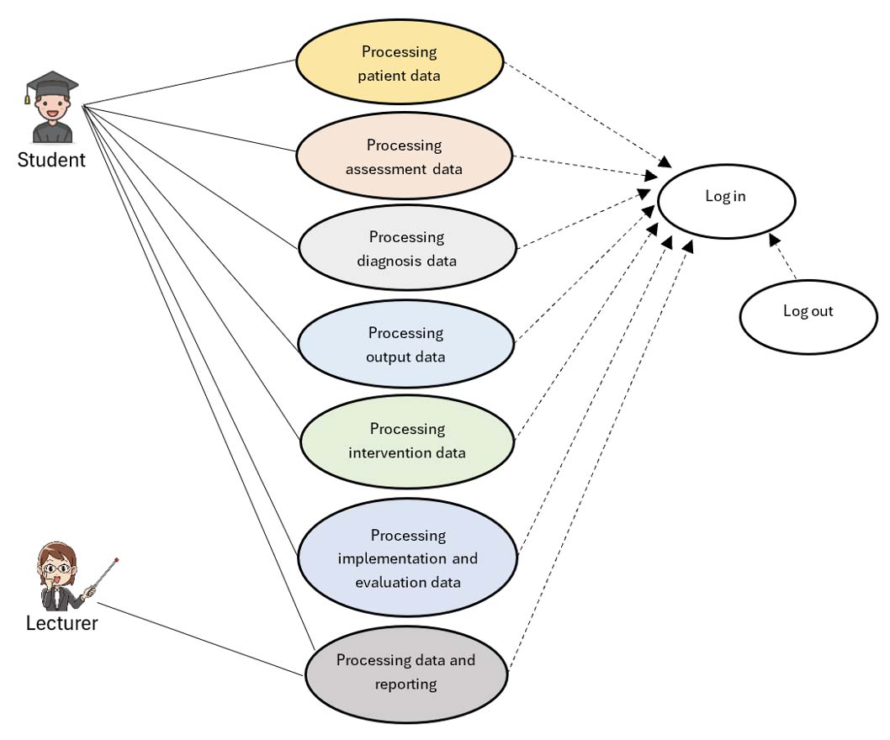

As shown in Figure 1, lecturers and students must log in first to use the nursing care system. After log in, the unique system service for students would be to access several features, including processing data related to patients, assessment, diagnosis, results, intervention, and implementation and evaluation. Meanwhile, the services that lecturers would access are data processing and nursing care results.

Development Implementation System

Log In Page
The log in menu page is the entrance for users of this information system. It is shown in Figure 2. Users need a username in the form of an email address and password to enter the system. Therefore, each user must be registered first if they want to access directly this nursing care system. If the user already has an email and password, the user can simply log in. The user’s email is entered in the Alamat Email input form, while the password is added to the Kata Sandi input form. Both are mandatory. If the user does not have email or password data, the user is not permitted to access the system.

Figure 2
Log In Page of the Web-Based Nursing Care Documentation Application
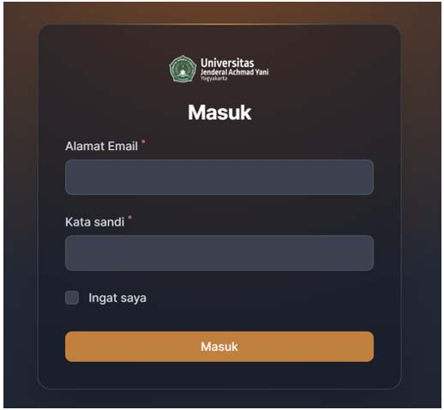

Home Page
The home page or dashboard is the front page displayed after the user logs in to the application. This page displays all menus according to the level of entry access so that users can create data on new and treated patients and organize nursing care from assessment to evaluation. Lecturers can also see this data, and they can explain to students what steps need to be taken. Users at the admin level can see all activities in the information system. The home page is shown in Figure 3.

Figure 3
Home Page of the Web-Based Nursing Care Documentation Application
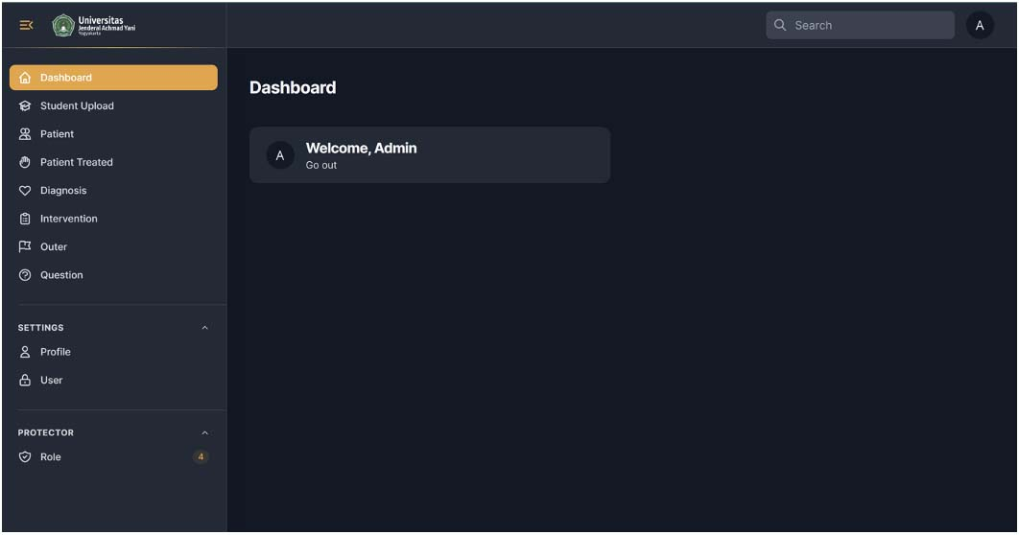

Patient Page
The patient page contains information on patients being treated and discharged. Meanwhile, the treated patients page contains data on patients being treated in the hospital who have yet to be discharged. The nurse can only see the dashboard menu, patients and treated patients, and the user profile. The patient page provides an overview of a patient’s identity: medical record number, name, medical diagnosis, status, admission date, and discharge date. Before providing patient nursing care, a nurse will enter data on the patient to be treated, including general patient information, medical history, head-to-toe assessment, and supporting examinations done for the patient. Furthermore, the assessment data determines patient nursing problems based on nursing care standards.

Diagnosis, Intervention, and Outcomes Page
This page, shown in Figure 4, contains nursing diagnoses that refer to current Indonesian nursing diagnosis standards. A diagnosis contains a code, diagnosis name, and category based on the system. After filling in the diagnosis, a user would continue filling in the expected results or goals to select nursing interventions. Nursing intervention reflects the nursing care plan provided to the patient. After filling in the nursing care plan, the nurse must fill out an implementation sheet based on the actions carried out on the patient. The completed implementation is then used as a form of evaluation by writing down subjective and objective data, analysis, and planning.

Figure 4
Diagnosis Page for the Web-Based Nursing Care Documentation Application
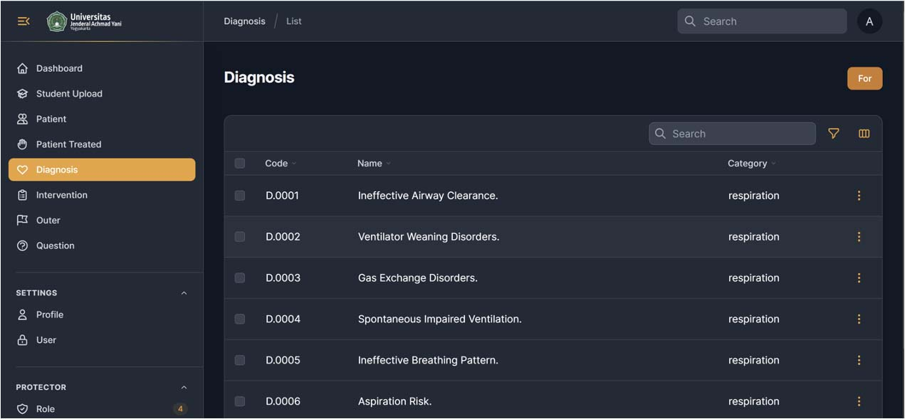

Testing
Usability testing was carried out on 15 nursing students who tried out the application during the Nursing Information Systems course. At the end of the test, students were asked to fill out a questionnaire containing 18 questions. Their responses were rated using a Likert scale (1 = strongly disagree to 5 = strongly agree). Usability testing results are shown in Table 1.
Table 1
Results of the Questionnaire on Student Perception of the Web-Based Nursing Care Documentation Application
Theme | Questionnaire item number and wording | Average Score
Usability | 1. The application website is easy to learn. | 4.3
Usability | 2. The application website interaction is clear and easily understandable. | 3.8
Usability | 3. The design of the application website is appropriate for system information design. | 4.1
Usability | 4. The application website is easy to use. | 3.9
Usability | 5. Attractive appearance of the application website. | 4.1
Usability | Average for all items related to usability | 4.0
Information | 6. The application website information is accurate. | 4.1
Information | 7. The application website information can be trusted. | 4.0
Information | 8. The application website information is relevant. | 3.9
Information | 9. The application website information is easy to understand. | 4.0
Information | 10. The application website information is in line with expectations. | 4.0
Information | Average for all items related to information | 4.0
Interaction | 11.The application website has a good reputation. | 4.0
Interaction | 12. Feel safe and comfortable using the application. | 4.0
Interaction | 13. The application website provides personalization space. | 3.9
Interaction | 14. The application website service corresponds to what is presented. | 4.0
Interaction | 15. The application website provides convenience and attracts attention. | 4.1
Interaction | Average for all items related to interaction | 4.0
Satisfaction | 16. Are you satisfied with the quality of use of the application website? | 4.2
Satisfaction | 17. Are you satisfied with the quality of information on the application website? | 4.0
Satisfaction | 18. Are you satisfied with the quality of interaction/service on the application website? | 4.0
Satisfaction | Average for all items related to satisfaction | 4.1
Note. N = 15.
The results of information system testing show that the nursing care information system can provide convenience, accuracy, and engagement.

Discussion
Nursing information systems are a combination of computer science, information science, and nursing science, which are designed to assist in processing nursing data, information, and knowledge to support nursing care practices for clients (Saba & McCormik, 2021). Through the use of nursing information systems, there is an increase in nurses’ knowledge of documenting nursing care (Saputra et al., 2020). In line with this research, the literature review shows that the use of information systems in nursing documentation provides satisfaction to nurses because they feel that information systems can make it easier to obtain information to support decision-making and make it easier to prepare nursing care (Riyani & Hariyati, 2022). Additionally, a nursing information system can make it easier for students to understand diagnoses in nursing care (Sinaga, 2019)
The use of web-based learning must be adjusted to users’ needs. It is hoped that attractive web-based media can draw students to study independently. However, web-based media must also be easy to access, use, and understand so students can learn outside the classroom (Figna et al., 2020).
Based on the usability dimension, which shows an average value of 4.0, the website application has good quality for users and features that are easy to learn and understand, easy to use, and have a user-friendly appearance and design. This shows that the features on the website application can run according to plan when tested on users. Meanwhile, the average value for the information dimension was also 4.0. This means that the information shown on the application is accurate regarding patient nursing care. Apart from that, the website application can produce reliable information, and the information provided regarding assessment results and diagnosis, intervention, and outcome data is easy to understand and relevant for users.
The findings for the interaction dimension also reached an average value of 4.0. This means that the application website has good quality and user interaction. The website application gives a positive impression to users because users feel safe when operating it, and it can attract users’ interest and attention. Finally, the findings on user satisfaction scored an average value of 4.1, which means the website application is designed very well and able to provide a sense of satisfaction for users, both in terms of the quality of interactions, the quality of information produced, and also the quality of interactions with users. Overall, the web-based nursing care application can help students carry out nursing care for patients easily and systematically. This aligns with research by Khairan et al. (2022), who revealed that usability, quality, and information in expert systems could influence the satisfaction of software users. Research conducted by Rustiawati et al. (2021) also revealed that using digital media in the learning process makes it easier for students to learn and respond quickly to complete their assignments due to its interactive nature.

Conclusion
This nursing care information system was created to help nursing students understand nursing care for patients even though learning is online. This web-based information system was developed based on the needs of user partners through needs analysis. The web-based nursing care information system refers to the nursing care standards applicable in Indonesia.
The usability testing results show that the nursing care information system developed is easy to understand, learn, and user-friendly. Students generally feel satisfied with the web-based nursing care information system. The results of student satisfaction with the web-based nursing care application show that the application can be used as a learning medium that helps students enrolled in online learning. However, developing a nursing care information system needs to be strengthened with a decision support system to make it easier for users to make diagnoses and provide nursing care. Besides, the stability of the Internet network in educational institutions must also be considered so that students can access web-based nursing care applications freely.

Declarations and Ethics Statements
The authors have no conflicts of interest to declare relevant to this article’s content.
The authors have approved the manuscript for submission.
All procedures performed in the current study involving human participants were in accordance with the ethical standards of the institutional research committee.
The datasets generated and analyzed during the current study are available from the corresponding author upon reasonable request.

References

Abidah, A., Hidaayatullaah, H. N., Simamora, R. M., Fehabutar, D., & Mutakinati, L. (2020). The impact of COVID-19 to Indonesian education and its relation to the philosophy of “Merdeka Belajar.” Studies in Philosophy of Science and Education (SiPoSE), 1(1), 38-49. https://doi.org/10.46627/sipose.v1i1.9
Asmirajanti, M., Hamid, A. Y. S., & Hariyati, R. T. S. (2019). Nursing care activities based on documentation. BMC Nursing, 18, Article 32. https://doi.org/10.1186/s12912-019-0352-0
Barisone, M., Bagnasco, A., Aleo, G., Catania, G., Bona, M., Scaglia, G. S., Zanini, M., Timmins, F., & Sasso, L. (2019). The effectiveness of web-based learning in supporting the development of nursing students’ practical skills during clinical placements: A qualitative study. Nurse Education in Practice, 37, 56-61. https://doi.org/10.1016/j.nepr.2019.02.009
Dinh, L. P., & Nguyen, T. T. (2020). Pandemic, social distancing, and social work education: Students’ satisfaction with online education in Vietnam. Social Work Education, 39(8), 1074-1083. https://doi.org/10.1080/02615479.2020.1823365
Figna, H. P., Rukun, K., & Irfan, D. (2020). The practicality and effectiveness of Web-based learning media. In Syamsir, E. Tasri, & H. Ardi (Eds.), Global conference series: Social sciences, education and humanities (vol. 5, pp. 51-56). Redwhite Press. https://series.gci.or.id/assets/papers/psshers-2020-344.pdf
Joshua, S. R., Akay, Y. V., Palilingan, K. Y. R., Kainde, H. V. F., Mapaly, H. A., & Lengkong, S. P. (2022). Paradigm of online learning in higher education. Jurnal Teknik Informatika Dan Teknologi Informasi, 2(1), 1-8. https://ejurnal.politeknikpratama.ac.id/index.php/jutiti/article/view/242
Khairan, A., Musfikar, R., Ilham, A. R., & Yusuf, B. (2022). Pengukuran kualitas penggunaan website sistem pakar diagnosa awal mental illness psikosis dengan metode WebQual [Measuring the quality of expert system website for early diagnosis of mental illness psychosis using the WebQual method]. Jurnal Ilmiah Komputer Grafis, 15(1), 66-82. https://journal.stekom.ac.id/index.php/pixel/article/view/713
Kristiana, I. F., Prihatsanti, U., Simanjuntak, E., & Widayanti, G. C. (2023). Online student engagement: The overview of HE in Indonesia. The International Review of Research in Open and Distributed Learning, 24(3), 34-53. https://doi.org/10.19173/irrodl.v24i3.7125
Laili, N., & Setiawan, L. (2021). Experience of online learning at nursing students. Jurnal Keperawatan Komprehensif, 7(2), 67-82. http://journal.stikep-ppnijabar.ac.id/index.php/jkk/article/view/242
Muhamat, N. A., Hasan, R., Saddki, N., Arshad, M. R. M., & Ahmad, M. (2021). Development and usability testing of mobile application on diet and oral health. PLoS ONE, 16(9), Article e0257035. https://doi.org/10.1371/journal.pone.0257035
Oducado, R. M. F., & Estoque, H. (2021). Online learning in nursing education during the COVID-19 pandemic: Stress, satisfaction, and academic performance. Journal of Nursing Practice, 4(2), 143-153. https://doi.org/10.30994/jnp.v4i2.128
Potter, P. A., Perry, A. G., Stockert, P. A., & Hall, A. M. (2021). Fundamentals of nursing (10th ed.). Elsevier.
Riyani, E., & Hariyati, S. T. Rr. (2022). Literature review: Kepuasan perawat dalam pendokumentasian asuhan keperawatan meggunakan sistem informasi di rumah sakit [Literature Review: Nurse satisfaction of nursing care documentation using information systems in hospitals]. Jurnal Keperawatan Muhammadiyah, 7(2), 176-181. https://journal.um-surabaya.ac.id/JKM/article/view/11499
Setiyani, L. (2021). Desain sistem: use case diagram. Prosiding Seminar Nasional : Inovasi & Adopsi Teknologi 2021, September, 246-260. https://journal.uii.ac.id/AUTOMATA/article/view/19517
Rohmani, N., & Andriani, R. (2021). Correlation between academic self-efficacy and burnout originating from distance learning among nursing students in Indonesia during the COVID-19 pandemic. Journal of Educational Evaluation for Health Professions, 18(9). https://doi.org/10.3352/JEEHP.2021.18.9
Rustiawati, E., Sulastri, T., & Yupartini, L. (2021). Pengaruh e-digital nursing care plans (E-DNCP) terhadap tingkat kepuasan mahasiswa tentang media pembelajaran dokumentasi keperawatan medikal bedah [The influence of e-digital nursing care plans (E-DNCP) on student satisfaction levels regarding medical surgical nursing documentation learning media]. Jurnal Keperawatan ’Aisyiyah, 8(2), 171-178. https://doi.org/10.33867/jka.v8i2.286
Saba, V. K., & McCormik, K. A. (2021). Essentials of nursing informatics (7th ed.). McGraw Hill.
Sinaga, R. (2019). Upaya peningkatan pembelajaran dokumentasi keperawatan dengan aplikasi asuhan keperawatan berbasis komputer pada mata kuliah dokumentasi keperawatan [Improving nursing documentation learning with computer-based nursing care applications in nursing documentation courses]. Jurnal Ilmu-Ilmu Kesehatan, 5(1), 1-10. https://ojs.akpergapu-jambi.ac.id/index.php/OjsGapu/article/view/31/pdf
Saputra, C., Arif, Y., Yeni, F. (2020). Andra’s Nursing Informatic System Application (Annisa) dalam upaya meningkatkan pengetahuan perawat tentang dokumentasi [Andra's Nursing Informatic System Application (Annisa) to increase nurses' knowledge about documentation]. Jurnal Keperawatan Silampari, 4(1), 20-30. https://doi.org/10.31539/jks.v4i1.1281
Zeng, X., & Wang, T. (2021). College student satisfaction with online learning during COVID-19: A review and implications. International Journal of Multidisciplinary Perspectives in Higher Education, 6(1), 182-195. https://files.eric.ed.gov/fulltext/EJ1299992.pdf

Web-Based Nursing Care Documentation for Students to Support Online Learning by Ngatoiatu Rohmani, Deby Zulkarnaen, and Puji Winar Cahyo is licensed under a Creative Commons Attribution 4.0 International License.

