MS Excel Practical Experiments – Aim & Sample

1. Creating Worksheets

Aim
To create and save worksheets using Microsoft Excel.

Practical Sample
- Open Excel
- Create a new workbook
- Enter student data
- Save the file as Student_Record.xlsx
Roll No | Name | Marks
101 | Amit Chauhan | 85
102 | Neha Chauhan | 90
103 | Rahul Chauhan | 78
104 | Amit Gohel | 85
105 | Neha Gohel | 90
106 | Rahul Gohel | 78
107 | Amit Jadav | 85
108 | Neha Jadav | 90
109 | Rahul Jadav | 78



2. Printing, Inserting, Deleting, Copying & Moving Worksheets

Aim
To perform worksheet management operations.

Practical Sample
- Insert a new worksheet
- Rename worksheet
- Copy Sheet1 to Sheet2
- Delete unwanted worksheet
- Print worksheet using Print Preview

Example
- Sheet Name: “Sales Report”
- Print Area: A1:D10
Sheet Name: Sales Report
Product | Quantity | Price | Total
Laptop | 2 | 4500 | 9000
Mouse | 5 | 5000 | 25000
Keyboard | 3 | 1200 | 3600
Apple | 200 | 5000 | 10000
Banana | 500 | 7000 | 45000
Mango | 300 | 3000 | 9000
Grapes | 500 | 8000 | 40000
Watermelon | 300 | 5000 | 15000

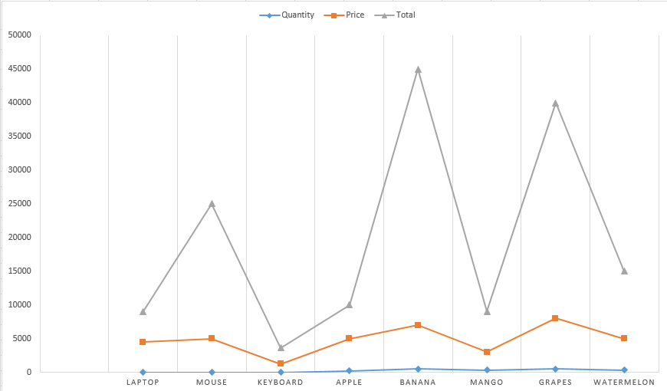

3.

Aim
To create and organize a fruit name list in Microsoft Excel using rows, columns, and tables, and to create charts for graphical representation of the data.
Sr. No | Category | Fruit Name | Sales
1 | Common Fruits | Apple | 10000
2 | Common Fruits | Banana | 10000
3 | Common Fruits | Mango | 5000
4 | Common Fruits | Orange | 10000
5 | Common Fruits | Grapes | 7000
6 | Common Fruits | Pineapple | 9000
7 | Common Fruits | Papaya | 10000
8 | Common Fruits | Watermelon | 7000
9 | Common Fruits | Guava | 8000
10 | Common Fruits | Strawberry | 10000

